Lab 6
Implementing Failover
Objective:
The purpose of this lab is for the student to understand basic features of and implement failover between firewalls. Students will also utilize IOS commands and a GUI to explore and configure a Cisco firewall.
Diagram:
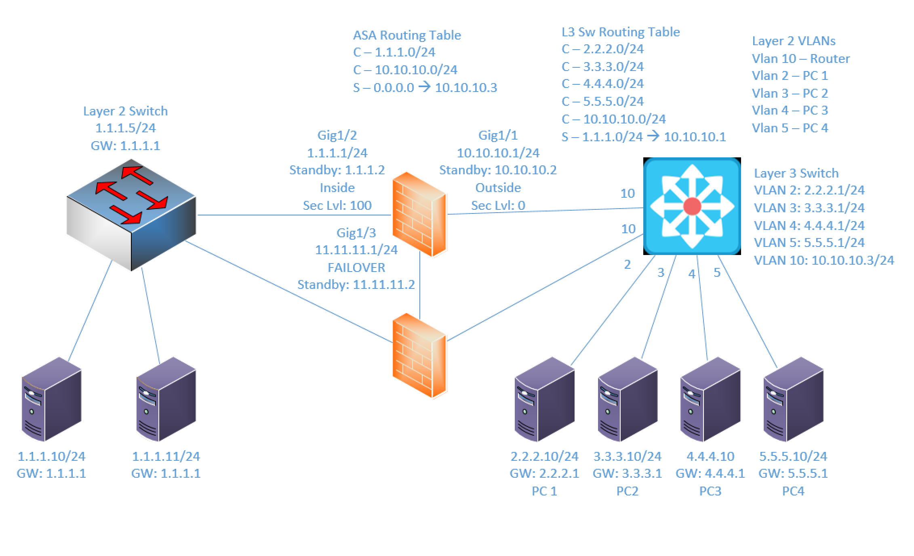
Components:
6 – PC’s
1 – Cisco 3650 Layer 2 Switch
1 – Cisco 3650 Layer 3 Switch
2 – Cisco ASA 5516-X Firewall

Useful commands for this lab:

show route – view ASA routing table
show interface ip brief – view status of ASA layer 3 interfaces
show nameif – view ASA interface names and security levels
show failover – view status of high availability

Configure Firewall Interface

int gigabitethernet1/1
nameif outside
security-level 0
ip add 2.2.2.1 255.255.255.0
no shutdown

Specify ASDM Location

dir flash:
config terminal
asdm image flash:asdm-742.bin !choose an asdm image in the list from previous command
write mem !save configuration
reload !reboot firewall

Allow Web Access (HTTPS)
http server enable
http 1.1.1.0 255.255.255.0 inside

Configure high availability settings (failover)

failover
!enable failover
failover lan unit primary
!– set local device to primary. Use Secondary for FW2
failover lan interface failover GigabitEthernet1/3
!set failover interface to gig1/3 and name it !“failover”
failover link failover GigabitEthernet1/3
!Configure link interface to gig1/3 and name it
!”failover”
failover interface ip failover 11.11.11.1 255.255.255.0 standby 11.11.11.2
!Ties all failover config together. Sets IPs used for !failover config. The name “failover” must match !previous commands
Procedure:
- Connect all PC’s to their appropriate switches and put their static IP addresses, subnet masks and gateways on them.

- Configure the IP address on firewall 1’s inside interface, set the name of the interface and the security level, and turn on the interface. Don’t worry about Firewall 2’s config for now. We’ll get to that later.

- Enable http access to the firewalls and allow the 1.1.1.0/24 network to access it from the inside interface on firewall 1.

- Ping the firewall’s inside interfaces from a machine on the inside network and verify it’s up and working.

- Connect to firewall 1’s GUI through the web browser.

- Select the configuration tab and under device setup select interfaces

- Create the Interfaces for the outside network.
  - List the interface details below: (screenshot if you prefer)
Interface | IP | Security Level | Name
Gig1/2 | 10.10.10.1/24 | 0 | Outside
- Select the firewall tab. Click on NAT Rules.

- Add a NAT rule that allows the 1.1.1.0/24 source to the outside networks destination and uses its original addresses. Remember how we did this in the previous lab: Create an object group, add each external network to the group. Use the object group as the destination address.

- On firewall 1, add an outside ACL rule that allows the external networks to get to 1.1.1.0/24 via ICMP.

- On firewall 1 add an inside ACL rule that allows 1.1.1.0/24 to get to the external networks via ICMP.

- Select Configuration Device Management High Availability Failover.

- Check enable failover. Under LAN Failover Select interface GigabitEthernet1/3.

- Give it an Active IP of 11.11.11.1 a standby IP of 11.11.11.2 and a subnet mask of 255.255.255.0. Select Preferred role as Primary.

- On stateful failover select GigabitEthernet1/3 interface. Click apply when finished.

- Click Interfaces and give the Inside interface a standby IP of 1.1.1.2. Give the Outside interface a standby IP of 10.10.10.2. Click apply when finished.

- Using the CLI on Firewall 2 turn on failover
  - What command did you enter?
failover

- On firewall 2 set the LAN interface failover and link failover to GigabitEthernet1/3
  - What commands did you enter?
failover lan interface FAILOVER Gi1/3
failover link FAILOVER Gi1/3

- Set the failover lan unit to secondary
  - What command did you enter?
failover lan unit secondary

- Set the interface failover IP to 11.11.11.1 and standby to 11.11.11.2

  - What command did you enter?
failover int ip FAILOVER 11.11.11.1 255.255.255.0 standby 11.11.11.2

- Turn on Interface GigabitEthernet1/3

  - What commands did you enter?
Int gi1/3
No shut

- What message shows up?
The primary firewall shows:
Beginning configuration replication: Sending to mate.
End Configuration Replication to mate
The secondary firewall shows:
Beginning configuration replication from mate.
End Configuration Replication from mate.

- How long do we have to wait? It was up within a few seconds

- Go to the CLI on firewall 1 and save the configuration to standby
  - What command did you enter? write memory

- After the waiting period view the configuration on firewall 2.

- Does it match firewall 1? yes
  - Why? We configured it to duplicate the configuration from the primary to the secondary ASA

- Can the PC’s ping both the active and standby IP’s? yes

- Can you open an GUI session to the inside standby IP? yes

- If you make a change on the primary does it reflect on the secondary automatically? Yes it does!

- Create the lab diagram below (PCs, router and switch connections) in Packet Tracer or Visio. Label the IP addresses, subnet masks, and gateways used by each device. Label the routing tables next to the switch and router and the switches vlan IP addresses and port vlan information. Label Failover ports, names and IP addresses.

